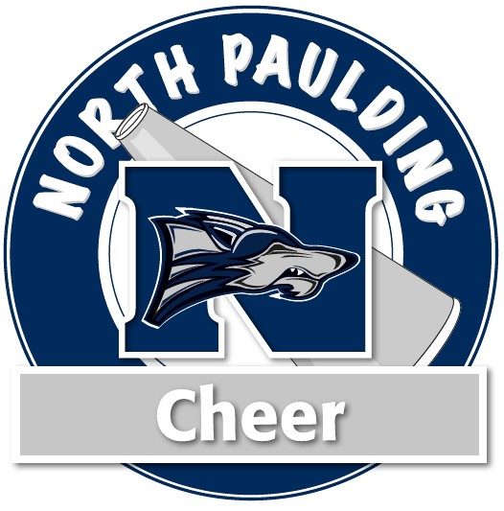

2020 North Paulding High School and Jr Wolfpack Cheerleading
Athlete Sponsorship

Cheerleader Name: Sponsor /Company Name: Address: City and Zip: Amount of Sponsorship:

* Note: $100.00 minimum required for name of sponsor on t-shirt. The size of the lettering will depend on the level of sponsorship.
* $100.00-$249.00 donation (small font)
* $250.00 - $499.00 donation (medium font)
* $500 and above (largest font)
* 100% of the donation will go toward the individual cheerleader’s account. Therefore, for cost purposes, we will not be placing a company logo on the sponsorship shirt.

Please make checks payable to: North Paulding Megaphone Club or NPMC -
Tax ID# 42-4241649—This is NON tax-deductible, it’s simply advertising!

